**RIPHAH INTERNATIONAL UNIVERSITY, ISLAMABAD**



**Lab Task 1**

**Subject:** Operating System Lab

**Submitted to:** Ma’am Kausar Nasreen Khattak

**Submitted by:** Areeba Sadaqat

**Sap Id:**47633

**Date:** 2th September, 2024

**Lab Task**

**Q1.** To begin, you need to set up a structured directory layout in your home directory. Start by creating two directories named **OS_Course** and **OS_Lab**. These directories will serve as the main folders for organizing your OS Lab tasks. After creating these directories, switch to the **OS_Lab** directory. Within OS_Lab, create three more directories named **LAB_Class_Task, LAB_Activities, and Lab_Practice**. Each of these directories will help you categorize different aspects of your lab work. Once you have created these directories, go into the **Lab_Practice** directory and create a file named example.cpp. This file should be empty and will be used for practice later. Finally, move back to your home directory. Make sure to take screenshots of each step, including the creation of directories, the file creation, and your navigation commands to document your process.

**Note:** Include screenshots, where required to illustrate your explanation.

**Solution:**

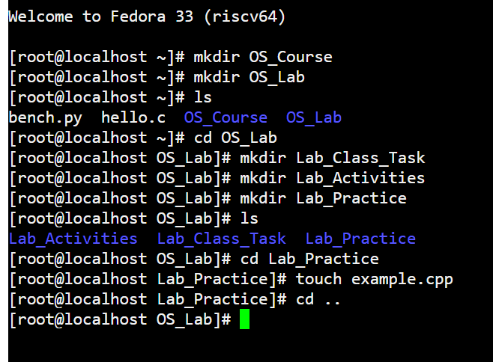

**Q2.** Finally, you need to understand the concepts of absolute and relative paths. Explain the difference between these two types of paths and provide an example of each. This will help you navigate directories more effectively. If you are currently in the Lab_Practice directory, describe the relative path to access the **LAB_Activities** directory. This will test your understanding of how to move between directories using relative paths.

**Note:** Include screenshots, where required to illustrate your explanation.

**Solution:**

**Absolute Path:** An absolute path is the complete path from the root directory to the desired file or directory. It always starts with a / and provides the full location of the file or directory in the system.

**Example:**

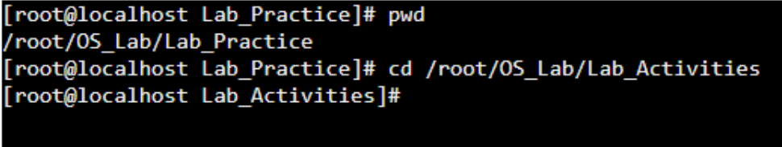

**Relative Path:** A relative path is the path to a file or directory relative to the current directory we are in. It is shorter than an absolute path because it only includes the steps needed to navigate from our current location.

**Example:**

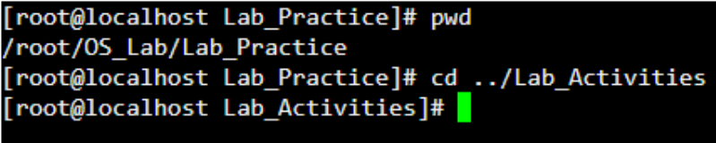

**Q3.** Imagine you’re working on your computer when you suddenly need to turn it off quickly. You press and hold the power button until the computer shuts down completely. After an hour, you turn the computer back on, and it quickly shows the login screen or desktop.

Why does your computer start up smoothly and quickly after being turned off? Describe the process that happens between powering off the computer and seeing the login or desktop screen. What steps does the computer go through to get everything ready in a short amount of time?

**Solution:**

When I shut down my computer by pressing and holding the power button, the computer undergoes a shutdown process. During this, the operating system (such as Windows or macOS) sends instructions to all active programs and services to save their current state and any open data. Once everything is properly saved, the operating system signals the hardware components to power off. When I turn the computer back on after an hour, the startup process begins. Initially, the computer performs a power-on self-test (**POST**) to ensure all hardware components are functioning correctly. Following this, the **BIOS** (Basic Input/Output System) is loaded, which initializes critical hardware components such as the CPU, RAM, and storage devices. Once the hardware is ready, the operating system is loaded from the storage drive into the computer’s memory. As the operating system loads, it begins initializing drivers for the hardware components, loading essential system services, and launching necessary processes.

The reason my computer starts up smoothly and quickly is due to the clean shutdown. When the computer is properly shut down, it saves the system state and ensures no programs or processes are left running in the background, allowing for a faster startup.